**Definitions**

* Times series plot is a scatterplot of the data with time on the x-axis in, typically, equally spaced intervals, and the observations on the y-axis
  + For visual clarity adjacent observations are connected by lines
  + The equally spaced intervals can be in units of years, months, days, hours,… and these units are called the period of the time series
* The level is the local mean of the observations, around which we see random noise
* When the level varies with time we say there is a trend.
* A seasonal effect is a systematic and calendar related effect which repeats with a given period
* Terms like level, trend and seasonality can only be defined precisely in terms of a modelling exercise.
* A change point is a time at which at least of the of the following changes
  + The data generation process
  + The way that the data is measured
  + The way that the observation is defined
* Stationarity informally means that the underlying random process does not change in time.
  + Seasonality, trends, non-constant variance and change points are all examples of non-stationarity.
  + If we have a stationary process we would be able to assume that, at least statistically, the future is similar to the past

**Time Series Models**

* Markov Chain is a form of stochastic iteration. It is a sequence Xi od dependent random variables where the distribution of Xn+1 depends on Xn and only on Xn. Which means
* If Xn takes values in the finite set S = {1, …, K}, it is a discrete space Markov chain
* If defines the K * K transition matrix, the n-step probabilities are defined as
* For large n the n-step transition probability often converge to equilibrium distribution which is independent of the past
* The following figure shows a realization of a 4-state Markov chain which has the transition matrix

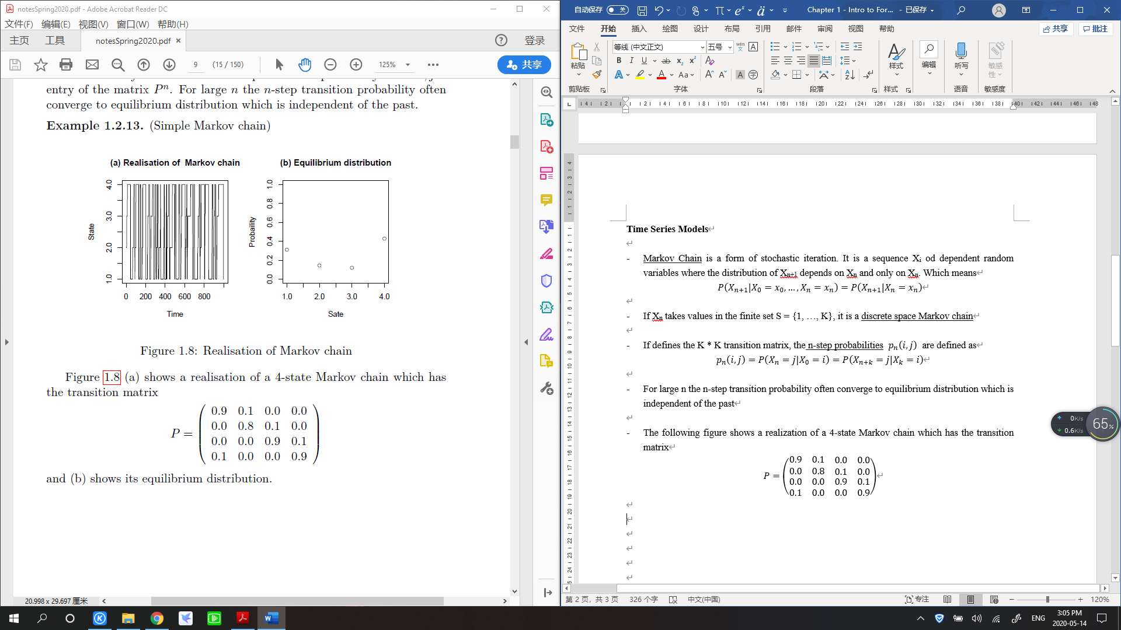

* And the following is its equilibrium distribution



* (random walk) Consider a continuous state space Markov chain. Let Zt, , be an i.i.d sequence of random variables. The series defined by
  + For t = 1, 2, …, is called a random walk
* A related Markov process has the following definition
* (Autoregressive model) Let Zt , , be an i.i.d sequence of random variables. The series defined by
  + For all , is called a first order autoregressive process (AR(1)) process.
* Note: not all time series have to be on discrete time points. If the time period of observation is arbitrary then we talk about continuous time stochastic processes
* (Brownian motion) A Brownian motion or Wiener process is a continuous-time stochastic process which is the unique process Wt which satisfies the following
  + W0 = 0
  + The function is almost surely everywhere continuous
  + The increments are independent when
  + The increment has a N (0, t-s) distribution for
    - We can think of the Brownian motion as a limit of the random walk when time intervals shrink to zero, and we illustrate a realized path in the following figure

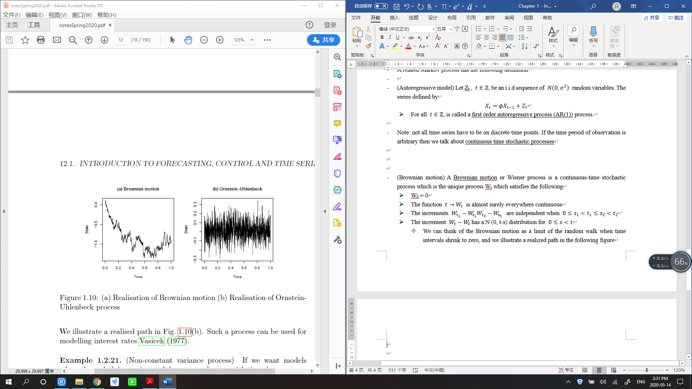

* (Non-constant variance process) if we want models where the underlying variance of the process changes with time then one possibility is to use an Auto-Regressive Conditional Heteroscedasticity (ARCH) model.
* We define the model by a hierarchically: first define where , but treat as being random such that
  + So the variance is time dependent – a large value of Xt will result in period of high volatility.
  + We illustrate an example of a realization in the following figure

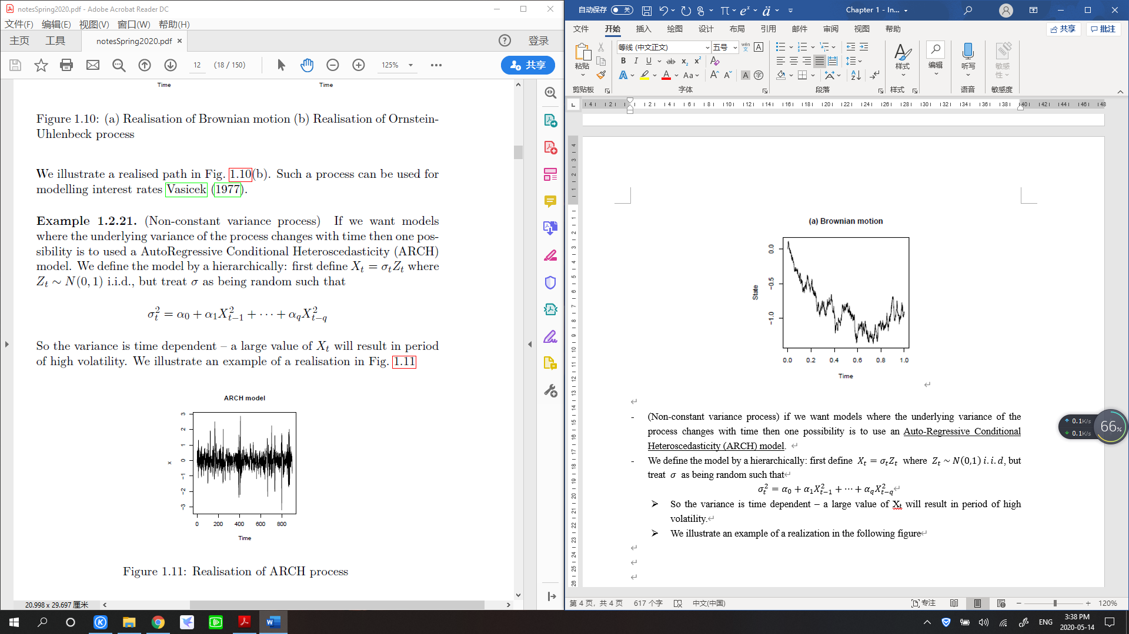

* (Gaussian process) let T = , then is a discrete Gaussian process if any finite subset has an n-dimensional multivariate normal distribution.
  + This model is completely determined when the mean and variance-covariance structures are known
* The following figure shows three realizations from three different one dimensional Gaussian processes.
  + They all share the fact that the realization gives a continuous graph but they differ in the “smoothness” of the realization.
    - This smoothness is controlled by a single parameter and the amount of “smoothness” increases as we go from left to right

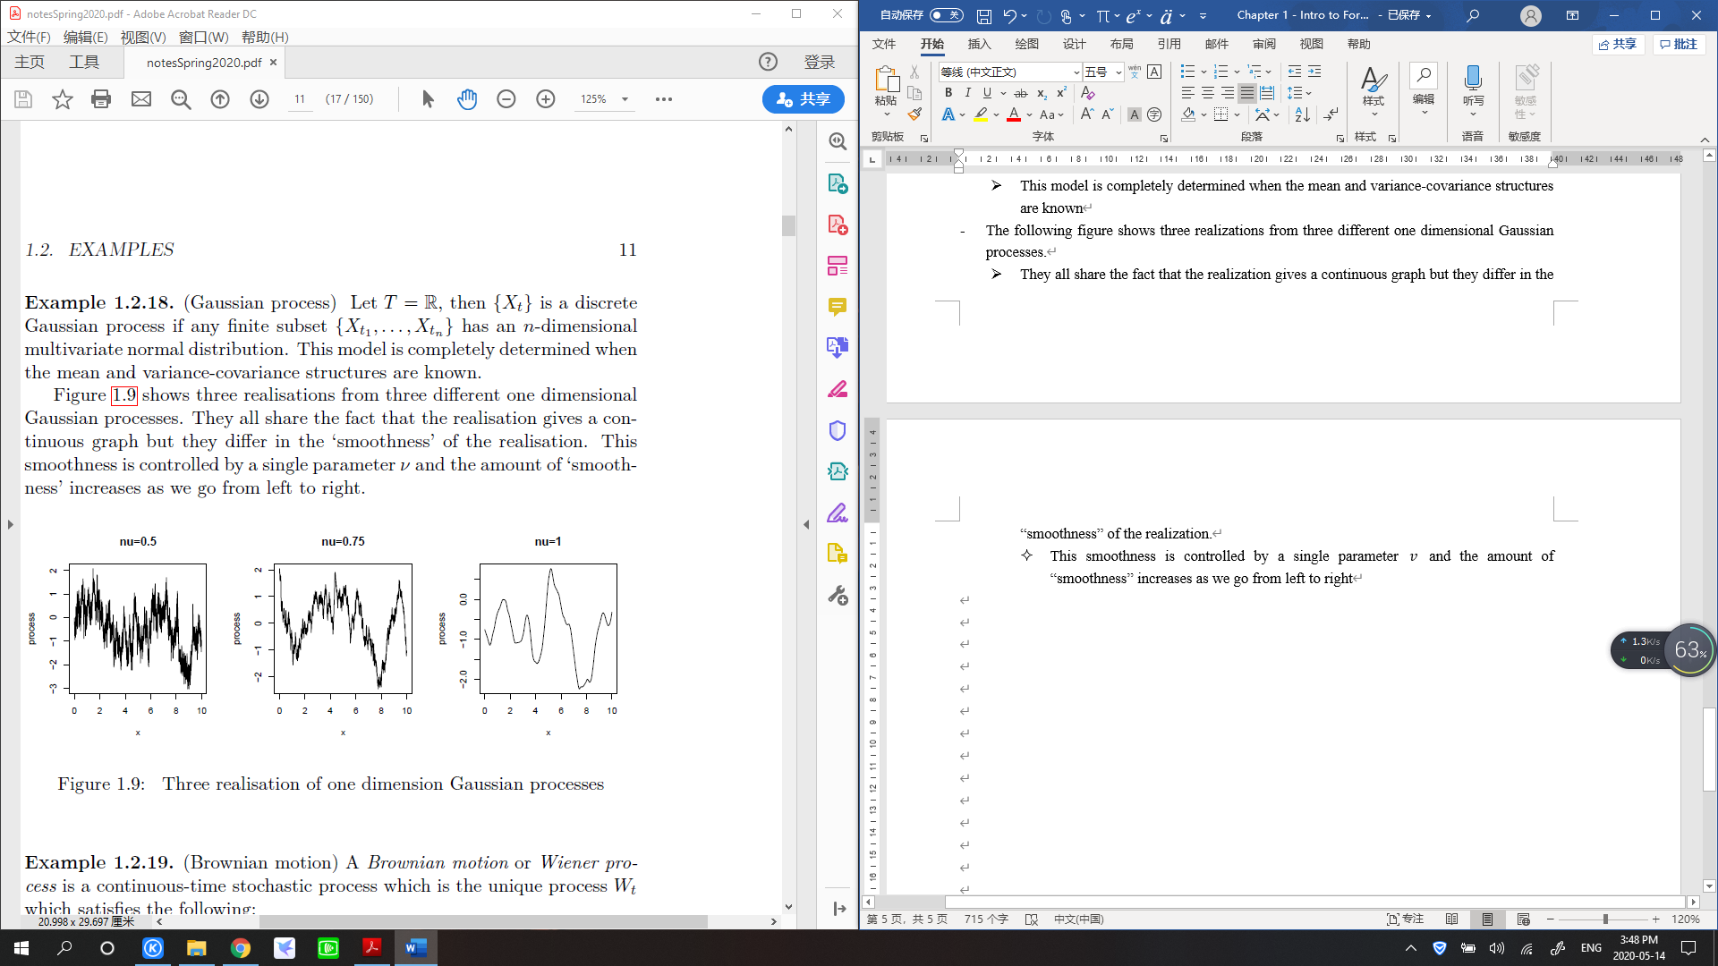

**Forecasting, Prediction and Control Problems**

* (**Housing Example**) The following figure (a) shows a summary statistic for the property market in San Diego, and the percentage change in price in (b)

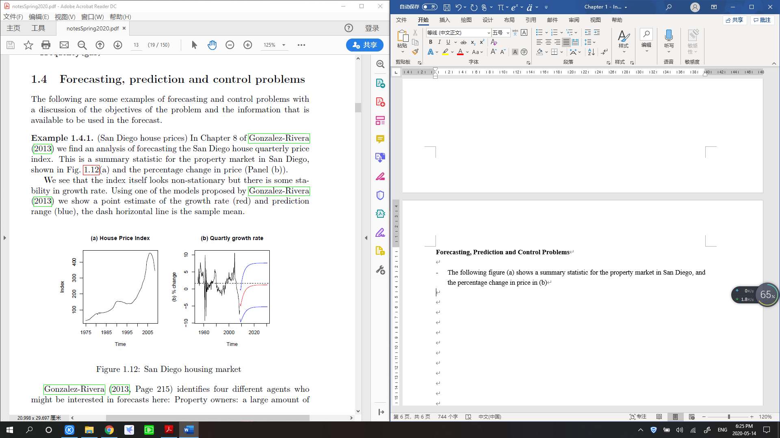

* We see that the index itself looks non-stationary but there is some stability in growth rate.
* Using one of the models proposed by Gonzalez-Rivera, we show a point estimate of the growth rate (red) and prediction range (blue), the dash horizontal line is the sample mean
* Different agents (property owners, real estate agents, …) may have different loss functions thus even with the same model we may have different forecasts.
  + E.g. the loss associated with overestimating the index may have, for some agents, a more sever effect than underestimating it, so asymmetric loss functions may be appropriate
* We can also think about the length of time that different agents may be interested in forecasting.
  + Someone thinking about selling a house in the next year would have four quarters as their forecast window, whereas a real-estate company may be interested in a much longer time scale.
  + In (b), it is qualitatively typical of many forecasts.
    - Short term forecasts – here a few quarters – are close to the current values,
    - But as the forecast window lengthens, the forecast converges to the (unconditional or marginal) mean of the sample
    - The variance of the forecast is smaller for short term forecast and grow until it convergences to (unconditional or marginal) variance of the sample.
  + For this to be valid we have to assume stationarity in the data.
    - In particular that the marginal mean and variance in the observed data are good representative for longer time periods
* Why are we only using the housing index itself as the sole source of information to make forecasts?
* The Efficient market hypothesis states that in an efficient market the price of an object always incorporates and reflects all relevant information
  + Should we look for other variables with predictive power? Or rather, is the housing market efficient?
* (**Prostate cancer Example**) Here the prediction problem is to estimate the level of a clinically important, but hard to measure directly, antigen value, using a number of variables which are easier to measure
* The problem can be thought of as a regression problem with the antigen being the response and the easy to measure variables possible explanatory variables.
  + There are many variable which have some correlation with the response – sharing much of the same information
  + We know from regression courses that the best prediction model is not the one that contains all possible explanatory variables
  + Rather we need to balance the simplicity of the model with goodness-of-fit.
* (**GDP Example**) The use of the forecast of GDP by a central bank was part of a control problem
  + i.e. deciding what value to set interest rates
* there is a strong relationship between statistical forecasting and control problems
* (**Spacecraft Example**) Forecasting questions are often part of a larger problem of how to control complex and noisy systems using feedforward and feedback loops.
* An example of this would be a navigation system on a robotic spacecraft.
  + The probe needs to be able to control its navigation using sensor data – which can be noisy – in a time sensitive way.
  + The forecast comes in answering the question:
    - What is the future position of the craft if current settings of the controls are kept stable?
    - And a related question of: how should be change the controls to ensure that the position o the spacecraft stays on target?
* State space methods including the Kalman Filter are a powerful tool in such control problems
  + The filter is a recursive method which uses statistical models to combine new measurements from the sensors relative to past information. It also determines up-to-date uncertainties of the estimates for real-time quality assessments.
* We have seen that in order to make forecasts we need to understand and model different forms of non-stationary. With complex systems it is not always clear if there is periodic behavior or what the period is.
* We can get insights into the periodic structure by representing the time series in the frequency domain
* (**Sunspot Example**) The left panel of the following figure shows the sunspot numbers from 1749 to 1983. We see a complex pattern of periodic behavior.
* The spectral decomposition of a time series decomposes the series into a sum of sinusoidal components with different frequencies. The right plot shows the size of these components by the frequency and we see a peak at between and which corresponds to an approximate cycle with period around 10 to 11 years.

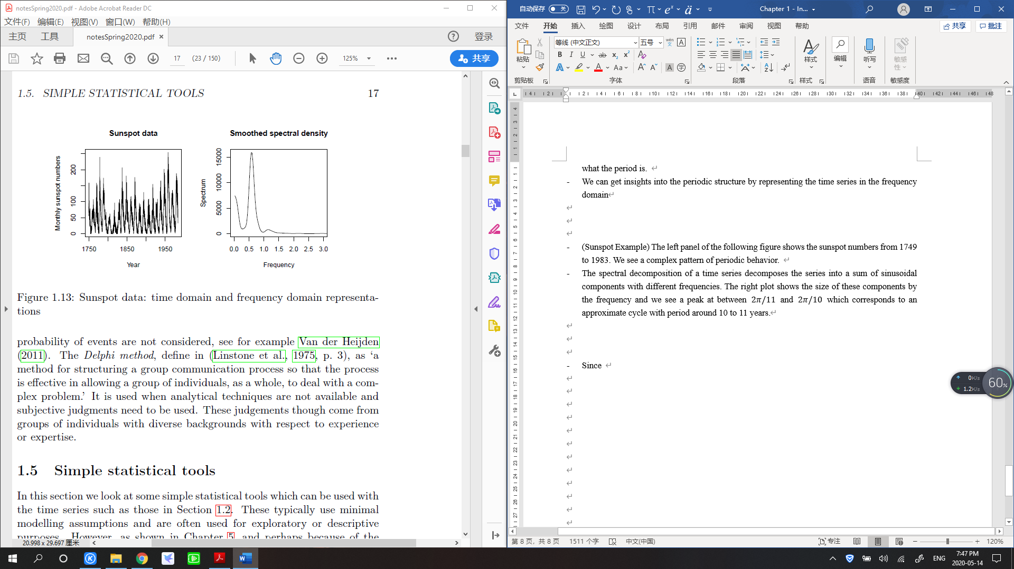

* Since this is a statistics course we focus our attention on methods which are fundamentally statistical – where information about the forecast is extracted from observed data, maybe through the use of a model.
  + For completeness we note that other methods are often used in practice
* (**Non-statistical forecasting method**s) Scenario analysis looks at the forecasting by considering a (small) finite number of alternative possible outcomes, by asking the question: “What if?” The probability of events are not considered.
* The Delphi method is defined as “a method for structuring a group communication process so that the process is effective in allowing a group of individuals, as a whole, to deal with a complex problem”
  + It is used when analytical techniques are not available and subjective judgments need to be used.
  + These judgments though come from groups of individuals with diverse backgrounds with respect to experience or expertise

**Simple Statistical Tools**

* This section looks at some simple statistical tools which can be used with the time series.
  + These typically use minimal modelling assumptions and are often used for exploratory or descriptive purposes.
  + However, they can be competitive when compared to much more complex models
* (Model with Trend) A trend model for the time series Xt is a decomposition
  + Where mt is a slowly varying function and Y­t has zero mean
    - Note that slowly varying means the change in the function is slow enough that we get a good estimate using the observed data.
    - An example could be
    - Here there are only a few parameters which are needed to be estimated so with a reasonable sample size we might make estimates which are good enough for purpose
  + Note that this definition is weaker than a regression models since we are not assuming anything about dependence structure of Yt nor its variance
* (Model with Seasonal Component) A model with a seasonal component with period d for Xt is a decomposition
  + - Where satisfies for all t
  + Simple examples would be monthly data with d = 12, weekly data with d = 52
* We can put trend and seasonal component together to get a linear decomposition model
* (Linear Decomposition Model) A linear decomposition model for the time series Xt is a decomposition
  + Where , is a slowly varying function, is periodic with period d and, for identification reasons we further assume

* We can construct a multiplicative decomposition model by applying a linear decomposition to
* In R we can estimate the components of the linear decomposition model by using the function *decompose (x, type = c(“additive”, “multiplicative”))*.
* (Example) we can see the result of this on the Ontario gas data.

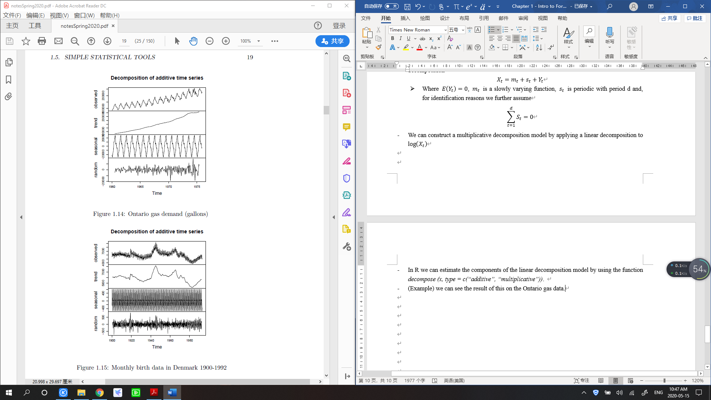

* The time series plot is on the top panel, an estimate of the trend mt in the second panel, an estimate of the seasonal effect, st in the third panel and the “residual” random term in the lower panel
  + We note that these models do not assume the usual regressive model conditions on the random term – in particular we see that we do not have constant variance and we say nothing about the dependence structure
* (Example) we can generate the result in R by implementing *plot (decompose (birth, type = “additive”))*.



* (Simple moving average filter) For linear decomposition model mentioned above we can estimate mt with moving average filter.
* Assuming that the period is even d = 2q, then the filter is defined on the realization xt by
* Since we have that , the seasonal component will not be part of this estimate
* We can then estimate the seasonal components. For each k = 1, …, d compute the average wk of
* We then normalize to get
* That is for monthly data we average over all January residuals, all February residuals etc.
* (Example) We can look at the Danish birth data, we can estimate the level, mt, using a 12 point moving average filter.
* The following figure shows both the raw data (black) and the estimated level which smooths out the seasonal component (red)

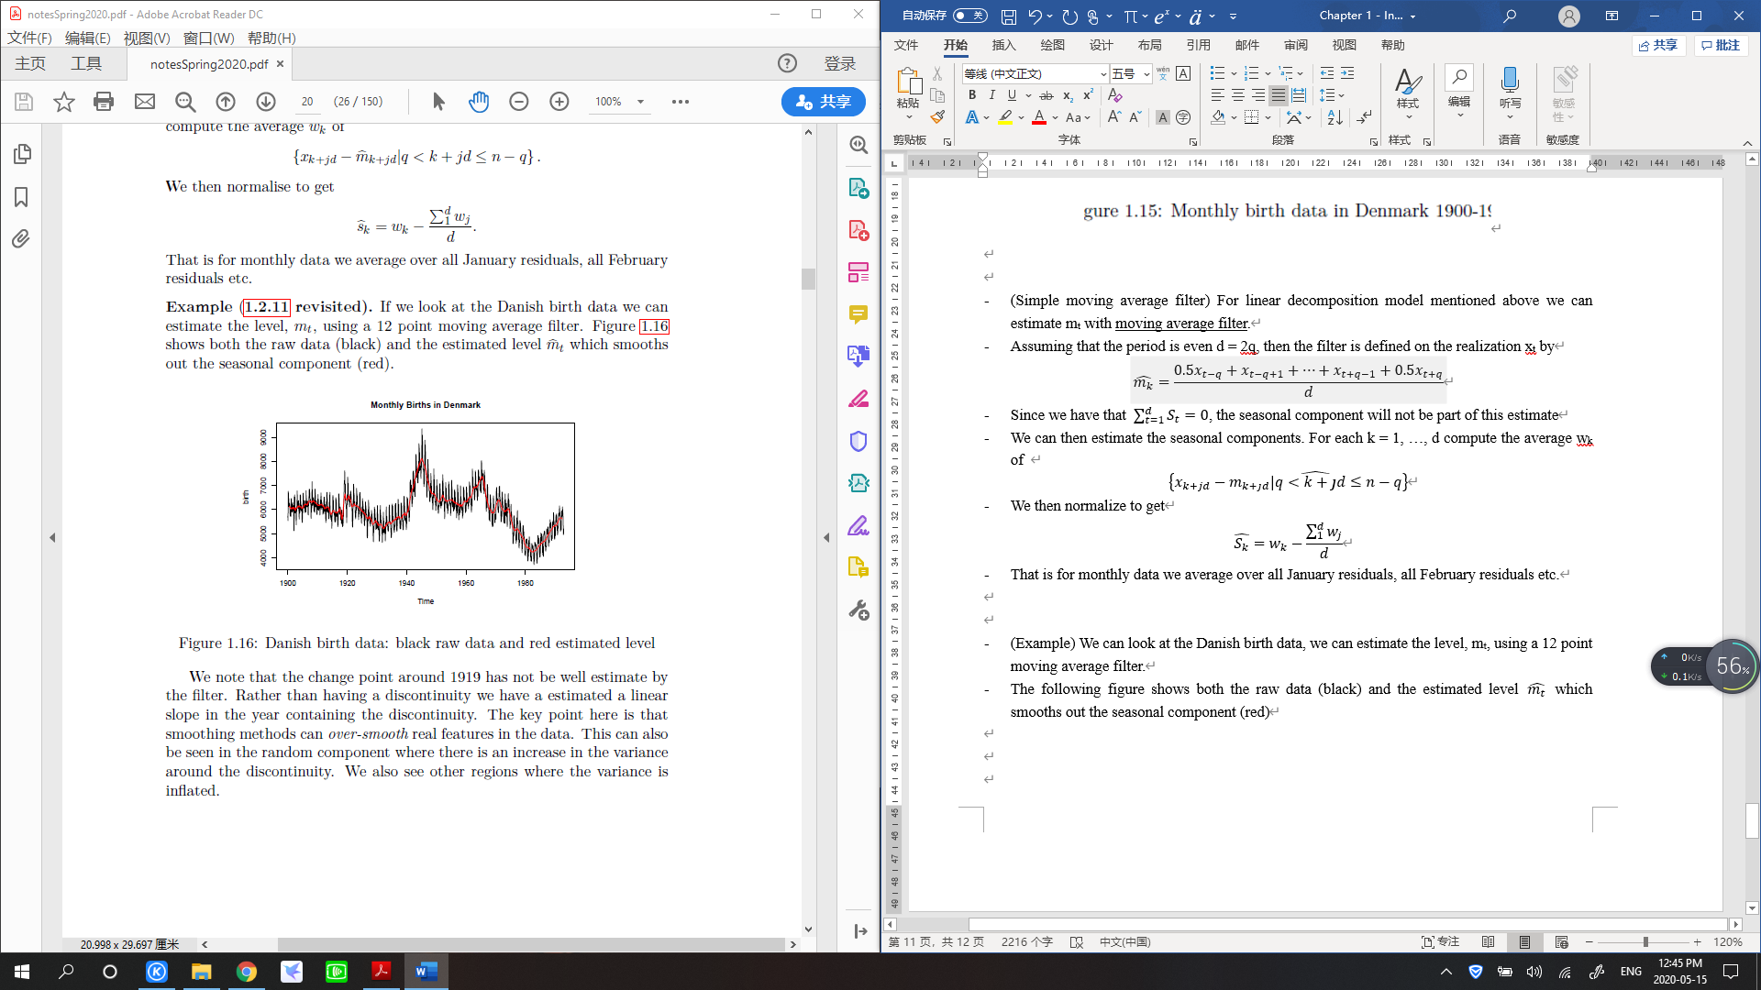

* We note that the change point around 1919 has not be well estimated by the filter. Rather than having a discontinuity we have estimated a linear slope in the year containing the discontinuity.
* The key point here is that smoothing methods can over-smooth real features in that data.
  + This can also be seen in the random component where there is an increase in the variance around the discontinuity.
* We also see other regions where the variance is inflated
* The moving average filter is not the only way of filtering the data.
* One disadvantage of it symmetric form is that it can only estimate the mt in the middle of the data.
  + This means it can’t be used directly for forecasting.
* There are other filtering methods which over come this. We look at a useful methods and related methods, exponential smoothing and, the more general, Holt-Winters filtering
* (Exponential smoothing) Exponential smoothing can be used for a time series to estimates the level of the process mt which is assumed slowing varying.
  + It should not be used when there is a trend or seasonality
* Assume that we can observe x1, …, xn. We select an initial value m0, typically x1, then we update the estimate recursively via the update equation
* The second form of the update is called the error correcting version and
  + Is the one-step ahead forecast error.
* The tuning parameter needs to be selected and this can be done by finding the which minimizes
* (Holt-Winters filtering) The Holt-Winters method generalizes exponential smoothing to the case where there is a trend and seasonality.
* We have three terms which depend on time t.
  + The first is a level at,
  + The second is the trend bt
  + The third is the seasonal component st.
* The terms at, bt are considered slowly varying and the mean of the time series at time t+h is given by
* The Holt-Winters prediction function for h time periods ahead of current t is
* The error term for this prediction is then defined as
  + Then starting with initial values for a, b and s and then update the parameters according to the size of the error over the range of t by using
  + The method uses three tuning parameters and these are selected by minimizing the sum of squared errors.
* (Example) we can apply the Holt-Winters method on the Denmark data and predicting using the result with the functions
* *Birth.hw = HoltWinters (birth)*
* *Birth.hw.predict = predict (birth.hw, n.ahead = 12 * 8)*
* The following figure shows the fit (red) and the forecast (blue) for the next 8 years.

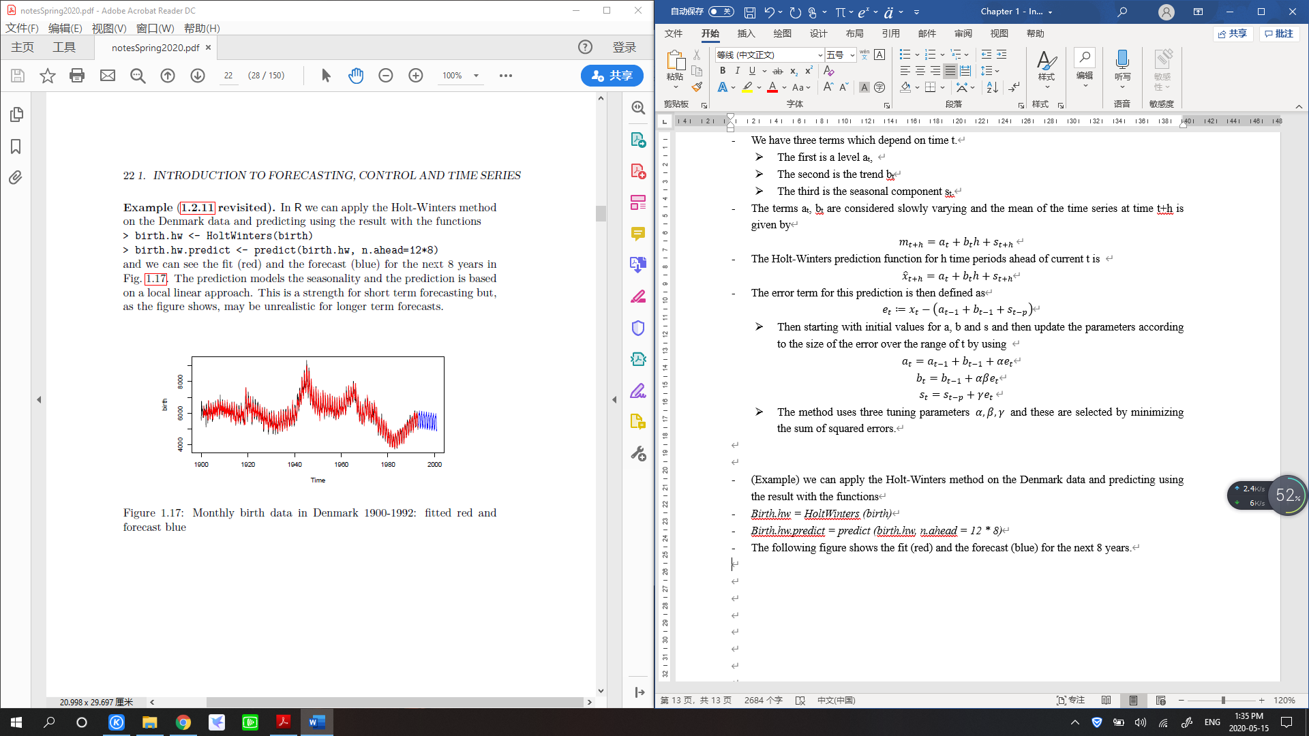

* The prediction models the seasonality and the prediction is based on a local linear approach.
* This is a strength for short term forecasting but, as the figures shows, may be unrealistic for longer term forecasts